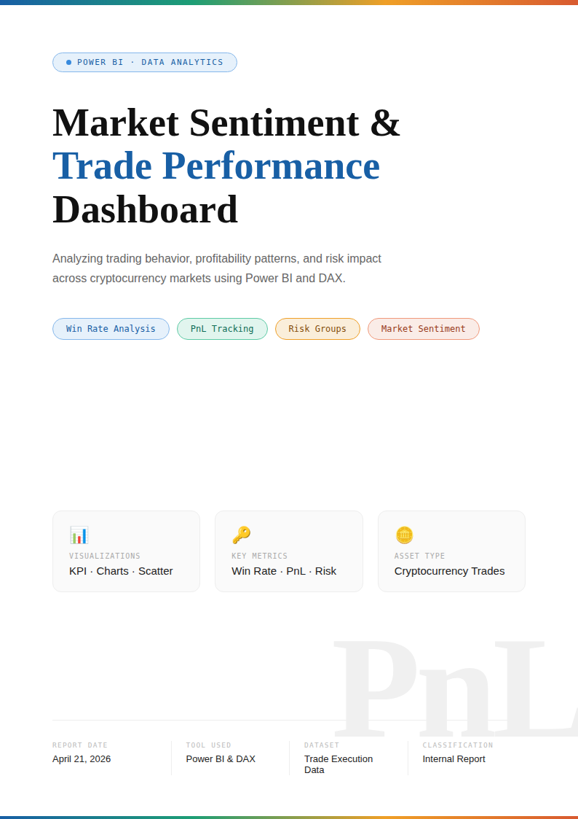

Introduction
This project focuses on analyzing trading performance using a dataset containing trade execution details such as coin, execution price, trade size, profit/loss, classification, risk level, and win/loss outcomes.
The main objective is to understand trading behavior, profitability patterns, and risk impact using data visualization in Power BI.

Objective
The key objectives of this analysis are:
- To evaluate overall trading performance using Win Rate and PnL
- To identify profitable coins and trading patterns
- To analyze the impact of classification (market sentiment) on performance
- To study risk levels and their influence on profitability
- To build an interactive dashboard for decision-making

Dataset Description
The dataset includes the following key columns:
- Coin – Cryptocurrency or asset traded
- Execution Price – Trade entry price
- Size USD / Tokens – Trade volume
- Side – Buy or Sell
- Closed PnL – Profit or loss from trade
- win – TRUE/FALSE outcome of trade
- Classification – Market sentiment/category of trade
- risk_group – Risk level of trade
- Timestamp / Date – Trade execution time
- Trade ID / Order ID – Unique identifiers

Data Preparation
The dataset was cleaned and transformed in Power BI:
- Converted TRUE/FALSE win column into numeric Win Flag (1/0)
- Handled missing or inconsistent values
- Ensured correct data types for numerical and date fields
- Created calculated measures for performance analysis

Key Measures Created
- Total Trades = Count of all transactions
- Total Wins = Sum of Win Flag
- Win Rate = Total Wins ÷ Total Trades
- Total Profit/Loss (PnL) = Sum of Closed PnL
- Loss Count = Total Trades − Total Wins

Visualizations Used
The dashboard includes the following visuals:

KPI Cards
- Total Trades
- Total Wins
- Total Losses
- Win Rate

Donut Chart
- Win vs Loss Distribution

Pie Chart
- Classification / Trade Type Distribution

Column Charts
- Coin vs Win Rate
- Coin vs Profit/Loss

Line Chart
- Performance trend over time (PnL / Win Rate)

Bar Chart
- Risk Group vs Performance

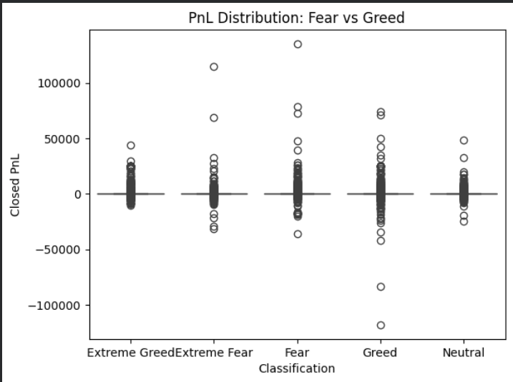
- Extreme Greed → higher positive outliers (big profits)
- Greed → also has very large losses (big negative outliers) ⚠️
- Fear → wide spread (high volatility)
- Extreme Fear → fewer large profits

Insight:
- Profit opportunities are highest in Extreme Greed
- But Greed has the highest downside risk
- Fear markets are highly volatile (unpredictable outcomes)
PnL distribution indicates that while Extreme Greed offers the highest upside potential, Greed periods expose traders to significant downside risk, and Fear markets exhibit high volatility.

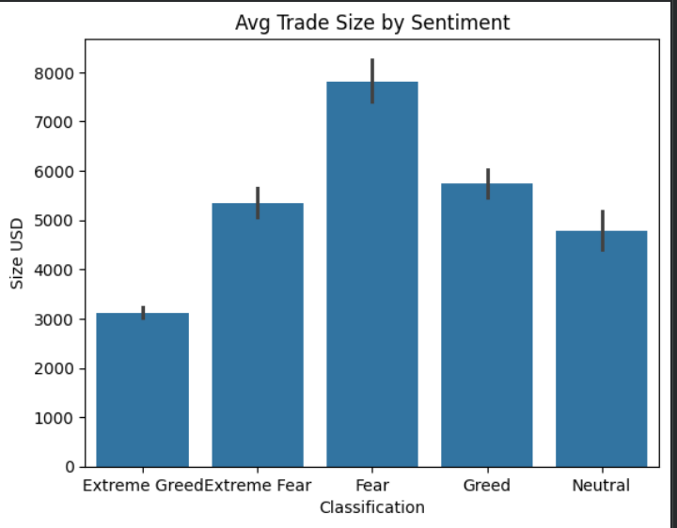
• Fear → highest trade size (~7800 USD) 🔥
• Greed → high (~5700 USD)
• Extreme Greed → lowest (~3100 USD)

Insight:
- Traders take biggest positions during Fear
- This is irrational behavior (risk ↑ when uncertainty ↑)

Traders increase position sizes during Fear periods, indicating riskier behavior under uncertainty, which may contribute to inconsistent performance.

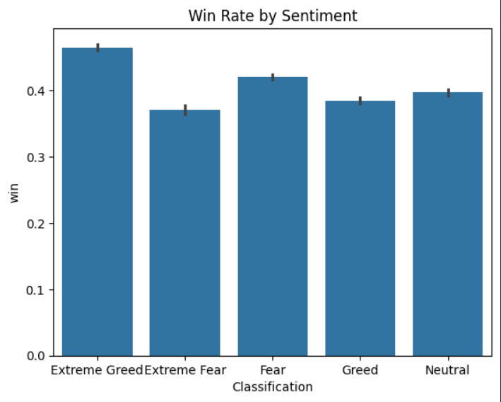
• Extreme Greed → highest win rate (~46%)
• Extreme Fear → lowest (~37%)

• Others → moderate

Insight:
- Best decision-making happens in strong trend markets
- Worst performance happens in panic conditions

Win rates peak during Extreme Greed, suggesting that strong market trends improve trading accuracy, while Extreme Fear leads to poor decision-making.

Actionable Output

Strategy 1: Defensive Approach During Fear
Rule:
- Reduce position size (since avg size is highest in Fear ~7800 USD)
- Limit number of trades (activity is highest in Fear)
- Trade only high-confidence setups
Why (from data):
- Fear shows high volatility (PnL spread)
- Lower win rate (~42%)
- Traders take excessive risk
Conclusion:
Fear markets lead to overtrading + overexposure → reduce risk.

Strategy 2: Trend-Based Trading in Extreme Greed
Rule:
- Follow market trend (momentum strategies)
- Slightly increase participation
- Maintain disciplined risk management
Why (from data):
- Highest PnL (~67.9)
- Highest win rate (~46%)
- Lower trade size → more controlled risk
Conclusion:
Extreme Greed offers the best trading conditions, but discipline is still required.

Strategy 3: Control Risk in Greed
Rule:
- Avoid large position sizes
- Always use stop-loss
- Avoid emotional/overconfident trades
Why (from chart):
- Greed shows large negative outliers (big losses)
- Indicates overconfidence risk
👉 Conclusion:
Greed is profitable but dangerous without control.

Key Insights
- Win Rate helps measure overall trading success
- Certain coins show higher profitability than others
- Classification impacts trade performance significantly
- Higher risk groups may show higher volatility in returns
- Scatter plot reveals trade efficiency patterns across price levels

Conclusion
This dashboard provides a clear and interactive view of trading performance and market behavior. It helps in identifying profitable strategies, understanding risk impact, and analyzing trading efficiency.
The insights generated can be used for better decision-making in trading strategies and risk management.

Tools Used
- Power BI
- Excel / CSV Dataset
- DAX (Data Analysis Expressions)
Final Dashboard View
